**Kingsway Christian College**

**Maths Department**

**Course**: Mathematics Methods Year 12

**Assessment Task**: Test 6 – Probability Distributions (Continuous)

**Student Name**: ________________________________________________________

**Date**: 24th & 25th August 2017

**Assessment Score**: ____________ / 70

**Year Score**: __________________

**Comments**: ________________________________________________________

___________________________________________________________________________

___________________________________________________________________________

___________________________________________________________________________

___________________________________________________________________________

___________________________________________________________________________

___________________________________________________________________________

___________________________________________________________________________

___________________________________________________________________________

**Teacher signature**: ________________________________________________________

**Parent/ Guardian signature**: _____________________________________________

**Comments**: ________________________________________________________

___________________________________________________________________________

___________________________________________________________________________

___________________________________________________________________________

___________________________________________________________________________

___________________________________________________________________________

**METHODS YEAR 12 Test 6 2017  
Probability Density Functions**

**Resource Free Time: 35 minutes Marks: / 35**

**Formula sheet provided but no extra notes or calculators allowed for this section.**

For any question or part question worth more than two marks, valid working or justification is required to receive full marks.

**Question 1 [4 marks]**

On a recent test, Bianca scored 70% and her standard score was 1. Riley sat the same test and her standard score was -0.5 when she scored 55%.

Calculate the mean and standard deviation for these test results.

**Question 2 [2, 3, 2, 2, 2 = 11 marks]**

The heights of fairy penguins in a particular geographic location are normally distributed with a mean height of 32 cm and a standard deviation of 1.5 cm.

Use the 68%, 95% and 99.7% rule to calculate each of the following.

(a) Determine the probability that a randomly selected fairy penguin is taller than 30.5 cm.

(b) Determine the probability of a randomly selected fairy penguin being shorter than 30.5 cm if it is known that they are in the 0.5 quantile.

(c) In a sample of 2000 penguins, how many would you expect to be taller than 35cm?

(d) What is the maximum height of the shortest 2.5% of penguins in this location?

(e) In a different geographic location the mean height of the fairy penguins found there is 33 cm. If 97.5% of the penguins are shorter than 35cm, and their heights are also normally distributed, what is the standard deviation for this population?

**Question 3 [3, 5 = 8 marks]**

Consider the probability density function drawn below:

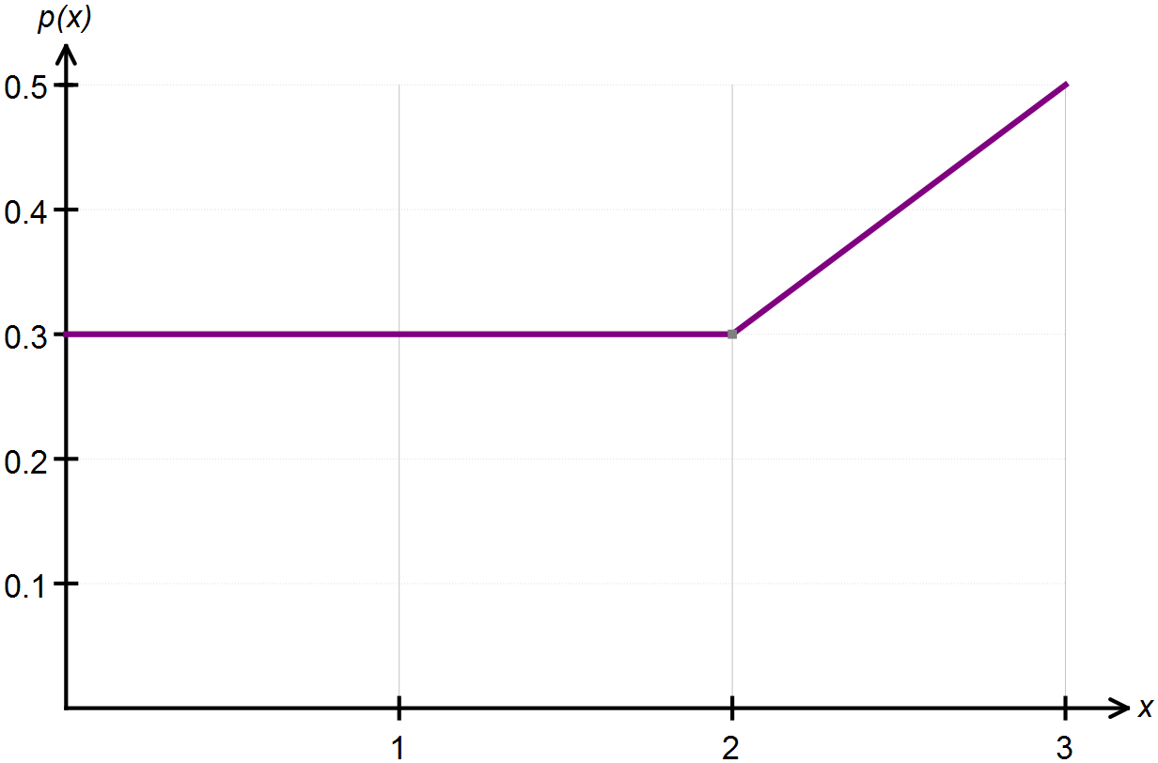

(a) Confirm, with appropriate calculations, that this above graph represents a probability density function.

(b) State the piecewise function that defines this continuous random variable.

**Question 4 [4, 4, 4 = 12 marks]**

Determine the value(s) of *k* which make each of the following functions a probability density

function.

(a) 

(b) 

(c) 

**END OF RESOURCE FREE SECTION**

**METHODS YEAR 12 Test 6 2017 Name:________________________  
Probability Density Functions: Continuous Distributions**

**Resource Assumed Time: 40 minutes Marks: / 35**

**CAS calculator allowed for this section.**

For any question or part question worth more than two marks, valid working or justification is required to receive full marks.

**Question 1 [2, 2, 2, 1 = 7 marks]**

A random variable *X* is normally distributed with a mean of 40 cm and a standard deviation of 3 cm.

(a) Calculate the value of *x* associated with a standardised score of  .

(b) Determine the value of the 85th percentile.

(c) Calculate  .

(d) Determine *k* for  .

**Question 2 [4 marks]**

Given that $X\sim N\left(μ; σ^{2}\right),$ find $μ$ and $σ$ if:

$P\left(X≥35\right)=0.1817$ and $P\left(X<40\right)$ = 0.9655

**Question 3 [3 marks]**

In a state spelling competition, results were normally distributed with a mean of 58% and a standard deviation of 14%.

Participants who scored between 85% and 95% received a certificate of distinction. In the state, 103 participants were awarded a certificate of distinction.

How many students participated?

**Question 4 [3, 2, 2, 3 = 10 marks]**

A new battery in an electric car has a charge that can last on average for 150 km of travel with a standard deviation of 21 km. Testing is underway to evaluate the performance of these batteries.

(a) Determine the probability that a randomly selected battery:

(i) Can be used for at least 140 km before it needs to be charged.

(ii) Can be used for more than 165 km if it is known that it can be used for at most 180 km.

(b) The worst performing 3% of batteries will be studied for their deficiencies. What is the maximum distance one of these batteries can be used for?

(c) In a sample of 250 batteries, how many would you expect to be in the 0.85 quantile?

(d) To improve the consistency of the battery performance, a team of engineers decide that at most 0.27% of batteries should last less than 100 km. Calculate the value of the new standard deviation for this normal distribution if the mean remains the same.

**Question 5 [2, 2, 2, 2, 3 = 11 marks]**

According to the Apple support site, the time taken to download a 2 hour movie using an ADSL2+ Broadband connection is uniformly between 18 and 24 minutes. Let T be the time taken to download one 2 hour movie from the Apple store.

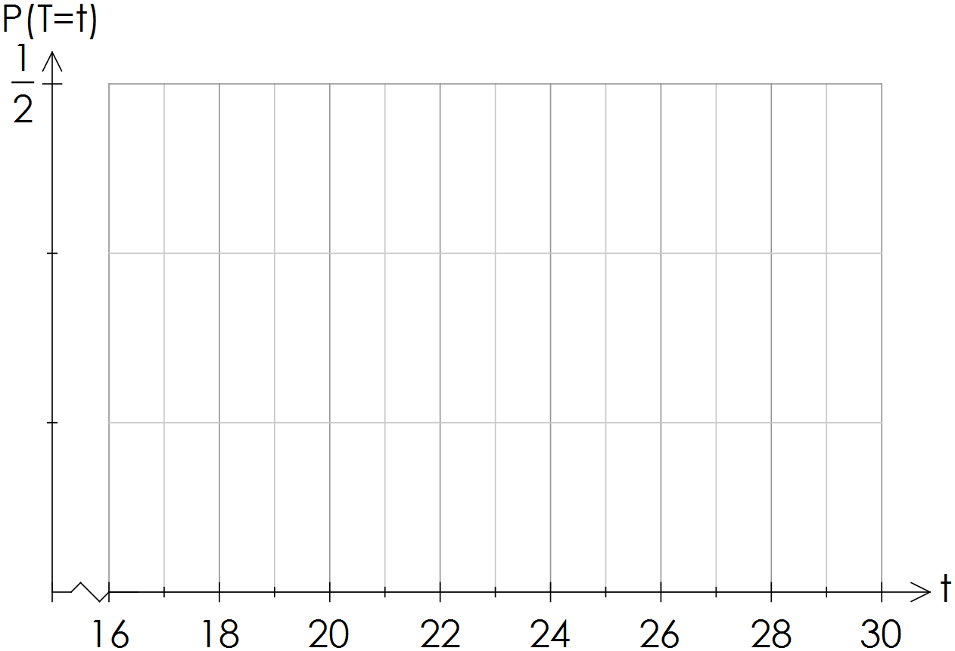(a) Sketch the probability distribution function for T.

(b) Calculate the mean time taken to download a movie.

(c) 75% of the time it takes less than *k* minutes to download a movie. Calculate the value of *k.*

(d) Calculate 

(e) This week, Dom has downloaded one movie each day. Determine the probability that exactly three of them took more than 22 minutes to download.

**END OF RESOURCE ASSUMED SECTION**